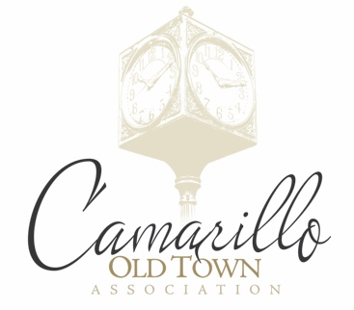
New Membership
Annual Renewal
Camarillo Old Town Association Member Application v072018

Company: __________________________________________________
Primary Contact: ____________________________Title: ______________
Address: ____________________________________________________
Phone: (_____)_______________________ Fax: (_____)______________
Website: ____________________________________________________
Email Address: ________________________________________________
Events and Areas of Interest: (Please circle any that you might have an interest in)
Beer March Wine Walk Boo Fest Christmas Snow/Tree lighting Car Shows Fiesta
Board Position Committee(s): Finance Events / Marketing Membership Volunteering
Payment Methods:
(Please check the intended method of payment)
Cash: Check: __________ Credit Card: Debit Card:
Master Card Visa
Discover American Express
Amount Due: $_________
Amount Paid: $____________
Card Number: _______ - _______ - _______ - ________ Exp Date: ____ / _____
Name of Card: ________________________________________ Security Code: ______
Signature: _________________________________________ Date: _____________
Authorization Agreement for Credit/Debit Card Charges
I hereby authorize the Camarillo Old Town Association, to initiate credit/debit charges to my credit/debit card indicated above. The credit/debit charges will appear within 3 to 10 business days of this applications submission.

Please submit your application to: Camarillo Old Town Association | PO Box 2732, Camarillo, CA 93011
Please email a copy of your logo to: Juliet.k@BellaCapriInn.com

